**HealthAI: Intelligent Healthcare Assistant Using IBM Granite**

**Project Documentation**

* **Introduction**

**Project Title: HealthAI Healthcare Assisant Using IBM Granite**

**Team Members**:

* Kamatchi L
* Keerthika M
* Jayam P
* Hasfiya Fathima M
* **Project Overview**

**Purpose:**

* The purpose of **HealthAI** is to empower healthcare providers, patients, and researchers by **leveraging AI** and **real-time data**. The system assists in **optimizing diagnosis**, **treatment**, and **patient management**, while also guiding healthy behaviors among individuals through personalized recommendations.
* For doctors and healthcare administrators, it serves as a decision-making **partner—offering** clear insights, **forecasting tools**, and summarizations of **medical** **documents** to support strategic planning**.**
* Ultimately, **this assistant bridges technology**, healthcare services, and patient engagement to foster healthier, more connected communities.

**Features:**

**• Conversational Interface Key Point:** Natural language interaction

**Functionality:** Allows patients and doctors to ask questions,get updates, and receive guidance in plain language

• **Medical Report Summarization Key Point:** Simplified report understanding

**Functionality:** Converts lengthy medical records into concise, actionable summaries

**• Health Forecasting Key Point:** Predictive analytics

**Functionality:** Estimates future health risks and patient outcomes using historical and real-time data

• **Personalized Health Tips Key Point:** Daily lifestyle advice

**Functionality:** Recommends diet, exercise, and preventive measures based on user behavior

• **Patient Feedback Loop Key Point:** Community engagement

**Functionality:** Collects and analyzes patient input to inform healthcare service improvements

• **KPI Forecasting Key Point:** Strategic planning support

**Functionality:** Projects key health performance indicators to help administrators track progress

**• Anomaly Detection Key Point:** Early warning system

**Functionality:** Identifies unusual patterns in patient vitals or medical records to flag potential issues

• **Multimodal Input Support Key Point:** Flexible data handling analysis and forecasting

• **Streamlit or Gradio UIKey Point:** User-friendly interface

**Functionality:** Provides an intuitive dashboard for both patients and file healthcare professionals

* **Architecture**
* **Frontend (Streamlit):** Interactive web UI for dashboards, uploads, chat, feedback, and medical report viewers.
* **Backend (FastAPI):** Provides **API** endpoints for document processing, chat, health tips, forecasting, and embeddings.
* **LLM Integration (IBM Watsonx Granite):** Used for medical document summarization, Q&A, and recommendations.
* **Vector Search (Pinecone):** Stores embeddings for patient records and allows semantic search.
* **ML Modules (Forecasting and Anomaly Detection):** Lightweight models for predicting patient outcomes and detecting anomalies.
* **Setup Instructions**
* **Prerequisites:**- **Python** **3.9** or later  
  -pip and virtual environment tools  
  -**APIkeysforIBM Watsonx** and Pinecone  
  - Internet access
* **Installation Process:**- Clone the repository  
  - Install **dependencies** from **requirements.txt**  
  - Create a **.env file** with credentials  
  - Run **backend** server with **FastAPI**- Launch **frontend** via **Streamlit**- Upload medical data and interact with modules
* **Folder Structure**
* **app/** – **FastAPI** backend logic
* **app/api/** – Modular API routes (chat, feedback, report, embeddings)
* **ui/** – **Streamlit** frontend components
* **health_dashboard.py** – Launches **Streamlit** dashboard
* **granite_llm.py** – Handles communication with **Watsonx** Granite model
* **document_embedder.py** – Embeds medical documents into Pinecone
* **health_forecaster.py** – Forecasts patient health trends
* **anomaly_checker.py** – Detects anomalies in health data
* **report_generator.py** – Constructs **AI-generated** health reports
* **Running the Application**
* Launch **FastAP**I server
* Run **Streamlit** dashboard
* Navigate pages via sidebar
* Upload health records and interact with assistant
* View outputs like reports, summaries, and predictions
* **API Documentation**
* **POST /chat/ask** – AI-powered Q&A
* **POST /upload-doc** – Upload and embed medical records
* **GET /search-docs** – Search similar patient records
* **GET /get-health-tips** – Personalized health tips
* **POST /submit-feedback** – Store patient feedback
* **Authentication**

**Supports:**

* Token-based authentication (JWT/API keys)
* OAuth2 with IBM Cloud
* Role-based access (doctor, patient, admin)
* **Planned:** session history tracking
* **User Interface**
* Minimalist design with sidebar navigation, KPI health visualizations, tabbed chat/forecasting layouts, real-time forms, and downloadable reports.
* **Testing**
* Testing includes unit testing (functions), **API testing** (Swagger/Postman), manual testing (uploads, responses), and **edge cases** (large files, invalid API keys).
* **Screenshots**

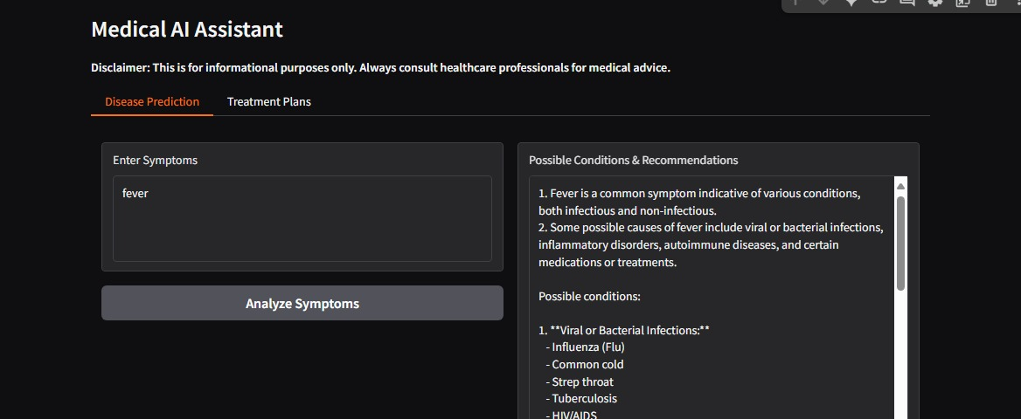

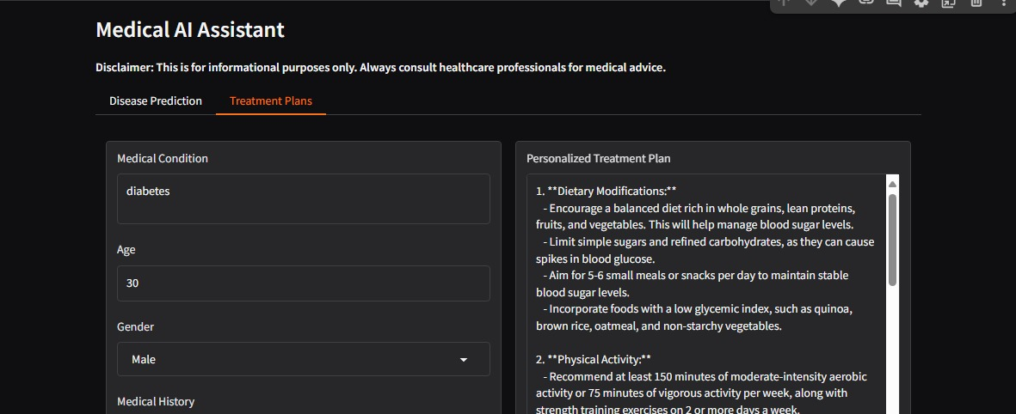

* **Known Issues**

**1. Data Quality & Availability**

• Incomplete, inconsistent, or biased datasets (e.g., underrepresentation of certain demographics).

• Missing values, incorrect labels, or unstructured medical notes.

**2. Bias & Fairness**

• AI models may perform poorly across different age groups, genders, or ethnic backgrounds.

• Risk of **reinforcing health** disparities.

**3. Explainability & Transparency**

• Many models **(especially deep learning)** act as “black boxes,” making clinical validation difficult.

• Lack of **interpretability** limits trust from doctors and patients.

**4. Integration with Healthcare Systems**

• Difficulty integrating with existing **EHR** **(Electronic Health Record) systems.**

• **Data silos** across hospitals and lack of **interoperability**.

**5. Privacy & Security**

• Handling sensitive patient data raises compliance issues **(HIPAA, GDPR, etc.).**

• Risk of data breaches and unauthorized access.

**6. Clinical Validation**

• AI tools may work well in lab settings but fail in **real-world** clinical environments.

• Limited large-scale trials for validation.

* **Future Enhancements**

**1.Improved Data Management**

**• Federated learning** for secure training without centralizing patient data.

**•** Standardized data formats for **interoperability.**

**2. Bias Reduction & Fair AI**

• Continuous monitoring for bias.

• Diverse datasets to improve fairness across populations.

**3. Explainable AI (XAI)**

•Development of **interpretable models** that provide reasoning behind predictions.

• Visualizations and clinician-friendly insights.

**4. Seamless Integration**

**• APIs** and middleware for smooth integration with **EHRs** and hospital systems.

• **Cloud-based** health AI platforms for scalability.

**5. Stronger Privacy & Security**

• Advanced **encryption** and **anonymization** techniques.

• Blockchain for secure patient record management.

**6. Clinical Adoption**

• AI-assisted decision support rather than full automation to build trust.

• Collaboration between clinicians and AI for hybrid decision-making.

**7. Regulatory Compliance & Standards**

• Clearer frameworks for medical AI approval.

**• Industry-wide ethical guidelines** for responsible AI use.

**8. Personalized & Preventive Healthcare**

• AI models that adapt to individual patient history and genetics.

• **Predictive analytics** for early disease detection and prevention.

* **Regulatory & Ethical Challenges**

• Regulatory approval is slow and complex.

• Ethical issues around **AI-driven** diagnosis and patient consent.